Universitatea Tehnică a Moldovei

Facultatea Calculatoare, Informatică şi Microelectronică

Departamentul Ingineria Software și Automatică

RAPORT

Lucrare de laborator nr.1

Disciplina: Programarea aplicatiilor mobile

Tema: Familiarizarea cu limbajul de programare Kotlin

A efectuat: Nica Ion, TI-203

A verificat: Stamatin Alexandru

Chişinău 2022

**Sarcina: Elaborarea unui program ce va afișa numărul de litera “a/A” găsite în text.**

**Linkul pe git:** https://github.com/Shutnikl/lab_1_pam.git

**XML File (DESIGN)**

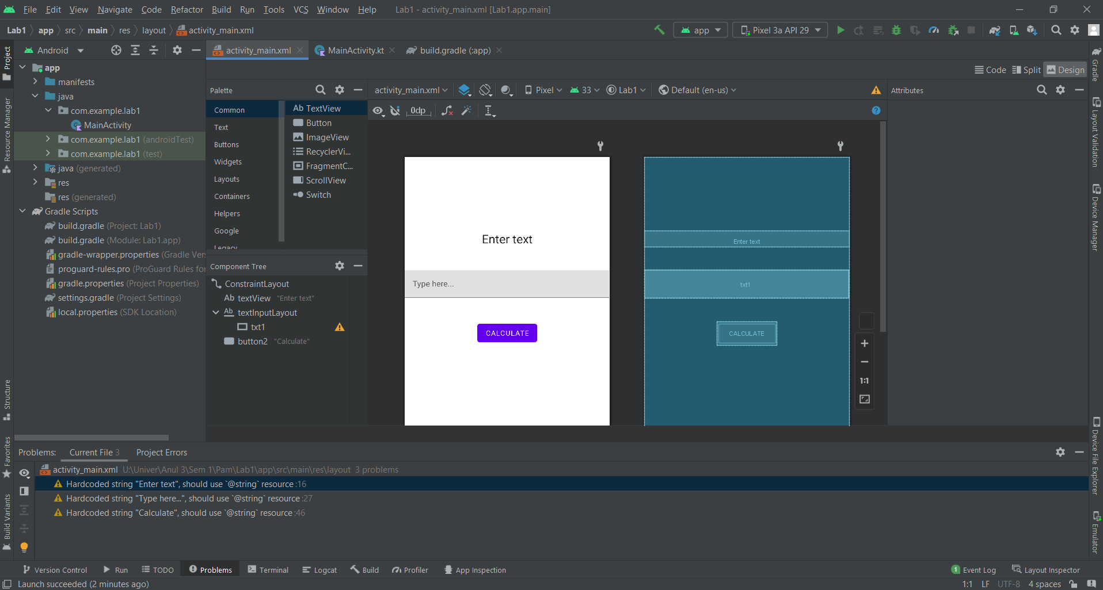

**KT FILE**

package com.example.lab1  
  
import androidx.appcompat.app.AppCompatActivity  
import android.os.Bundle  
import androidx.appcompat.app.AlertDialog  
import com.example.lab1.databinding.ActivityMainBinding  
  
  
class MainActivity : AppCompatActivity() {  
 private lateinit var binding: ActivityMainBinding;  
 override fun onCreate(savedInstanceState: Bundle?) {  
 super.onCreate(savedInstanceState)  
 binding = ActivityMainBinding.inflate(*layoutInflater*)  
 setContentView(binding.*root*)  
 binding.button2.setOnClickListener **{** getResult() **}** }  
  
 private fun getResult() {  
 binding.textInputLayout.*helperText* = validText()  
 val validText = binding.textInputLayout.*helperText* == null  
 if (validText)  
 showResult()  
  
 }  
 private fun calculateOccurance(txt: String) : Int  
 {  
 val strArray = txt.*split*("".*toRegex*()).*toTypedArray*()  
 var word = 0  
 for (s in strArray) {  
 if ("a" in s || "A" in s && s != "") {  
 word++  
 }  
 }  
 return word  
 }  
 private fun showResult()  
 {  
 val txt = binding.txt1.*text*.*toString*()  
 val message = "Number of letter A in string: " + calculateOccurance(txt)  
 AlertDialog.Builder(this)  
 .setTitle("Result")  
 .setMessage(message)  
 .setPositiveButton("Okay")**{** _,_ **->** binding.txt1.*text* = null  
 **}** .show()  
 }  
  
 private fun validText(): String? {  
 val text = binding.txt1.*text*.*toString*()  
 if (text.*trim*().*isEmpty*()) {  
 return "Text missing"  
 }  
 return null  
 }  
}

XML File

<?xml version="1.0" encoding="utf-8"?>  
<androidx.constraintlayout.widget.ConstraintLayout xmlns:android="http://schemas.android.com/apk/res/android"  
 xmlns:app="http://schemas.android.com/apk/res-auto"  
 xmlns:tools="http://schemas.android.com/tools"  
 android:layout_width="match_parent"  
 android:layout_height="match_parent"  
 tools:context=".MainActivity">  
  
 <TextView  
 android:id="@+id/textView"  
 android:layout_width="match_parent"  
 android:layout_height="wrap_content"  
 android:layout_marginTop="148dp"  
 android:fontFamily="sans-serif"  
 android:gravity="center_horizontal"  
 android:text="Enter text"  
  
 android:textAlignment="center"  
 android:textAppearance="@android:style/TextAppearance.Material.Headline"  
 app:layout_constraintEnd_toEndOf="parent"  
 app:layout_constraintTop_toTopOf="parent" />  
  
 <com.google.android.material.textfield.TextInputLayout  
 android:id="@+id/textInputLayout"  
 android:layout_width="match_parent"  
 android:layout_height="wrap_content"  
 android:hint="Type here..."  
 android:layout_marginTop="47dp"  
 android:layout_marginEnd="1dp"  
 app:layout_constraintEnd_toEndOf="parent"  
 app:layout_constraintTop_toBottomOf="@+id/textView">  
  
 <com.google.android.material.textfield.TextInputEditText  
 android:id="@+id/txt1"  
 android:layout_width="match_parent"  
 android:layout_height="wrap_content"  
 android:fontFamily="sans-serif" />  
 </com.google.android.material.textfield.TextInputLayout>  
  
 <Button  
 android:id="@+id/button2"  
 android:layout_width="wrap_content"  
 android:layout_height="wrap_content"  
 android:layout_marginTop="47dp"  
 android:fontFamily="sans-serif"  
 android:text="Calculate"  
 app:layout_constraintEnd_toEndOf="parent"  
 app:layout_constraintStart_toStartOf="parent"  
 app:layout_constraintTop_toBottomOf="@+id/textInputLayout" />  
  
</androidx.constraintlayout.widget.ConstraintLayout>

**Android APP**

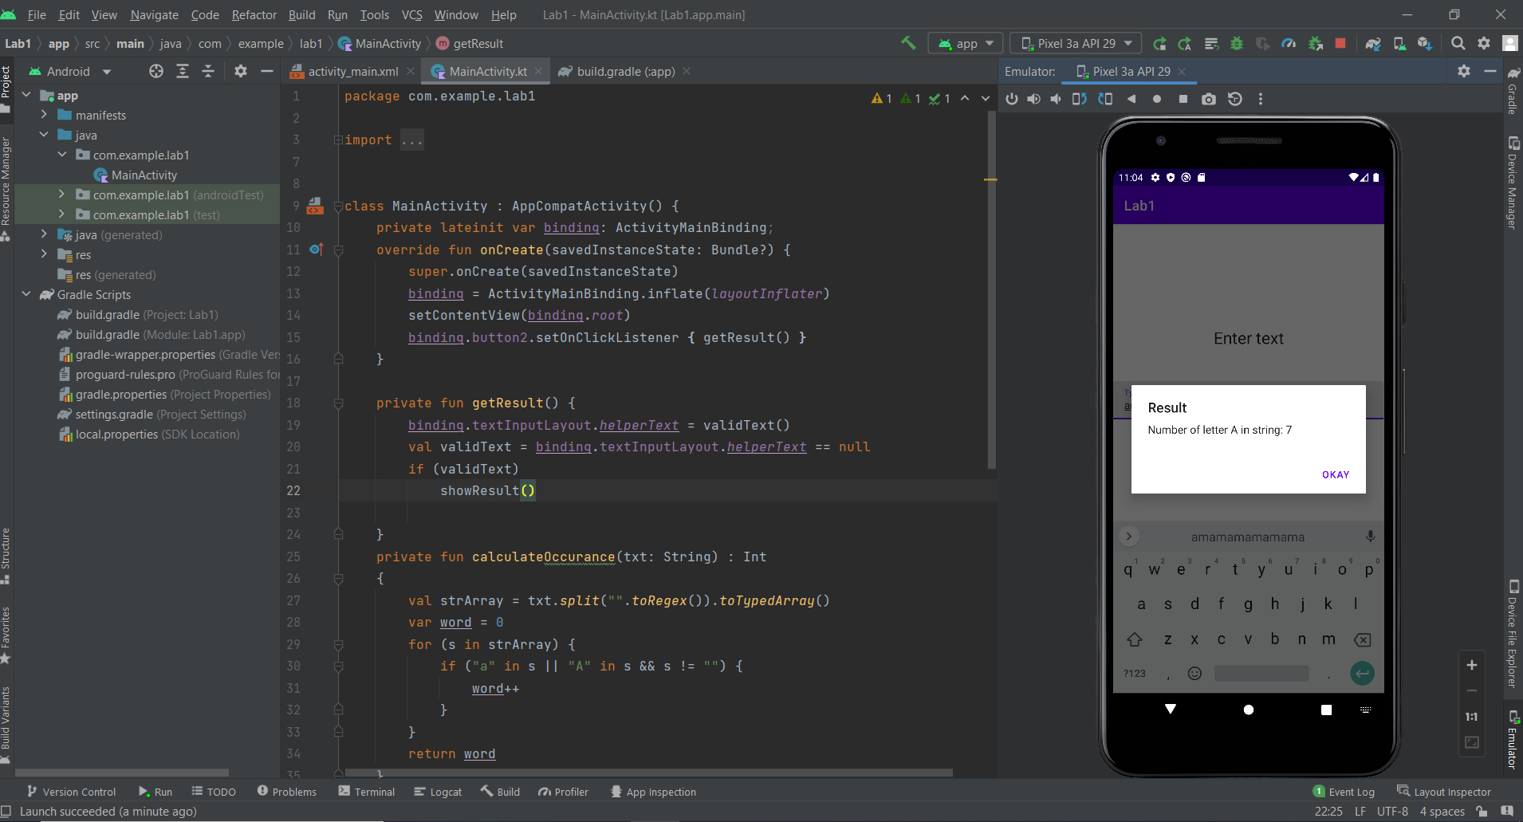

**Build.gradle**

plugins **{** id 'com.android.application'  
 id 'org.jetbrains.kotlin.android'  
 id 'kotlin-kapt'  
**}**android **{** compileSdk 32  
  
 defaultConfig **{** applicationId "com.example.lab1"  
 minSdk 21  
 targetSdk 32  
 versionCode 1  
 versionName "1.0"  
  
 testInstrumentationRunner "androidx.test.runner.AndroidJUnitRunner"  
 **}** buildTypes **{** release **{** minifyEnabled false  
 proguardFiles getDefaultProguardFile('proguard-android-optimize.txt'), 'proguard-rules.pro'  
 **}  
 }** compileOptions **{** sourceCompatibility JavaVersion.*VERSION_1_8* targetCompatibility JavaVersion.*VERSION_1_8* **}** kotlinOptions **{** jvmTarget = '1.8'  
 **}** buildFeatures**{** viewBinding true  
 **}  
}**dependencies **{** implementation 'androidx.core:core-ktx:1.7.0'  
 implementation 'androidx.appcompat:appcompat:1.5.1'  
 implementation 'com.google.android.material:material:1.6.1'  
 implementation 'androidx.constraintlayout:constraintlayout:2.1.4'  
 testImplementation 'junit:junit:4.13.2'  
 androidTestImplementation 'androidx.test.ext:junit:1.1.3'  
 androidTestImplementation 'androidx.test.espresso:espresso-core:3.4.0'  
**}**

Concluzii:

In aceasta lucrare de laborator am elaborate o aplicatie care va numaru numarul de litere A intrun sir de caractere scrise de noi.

TextView am folosit pentru comentariu ca spre exemplu: Introdul textul. Tot aici pentru design am folosit si textinputlayout si button.TextInputLayout am folosit pentru a putea introduce textul in caseta si Button este folosit pentru a porni calcularea literelor din text.